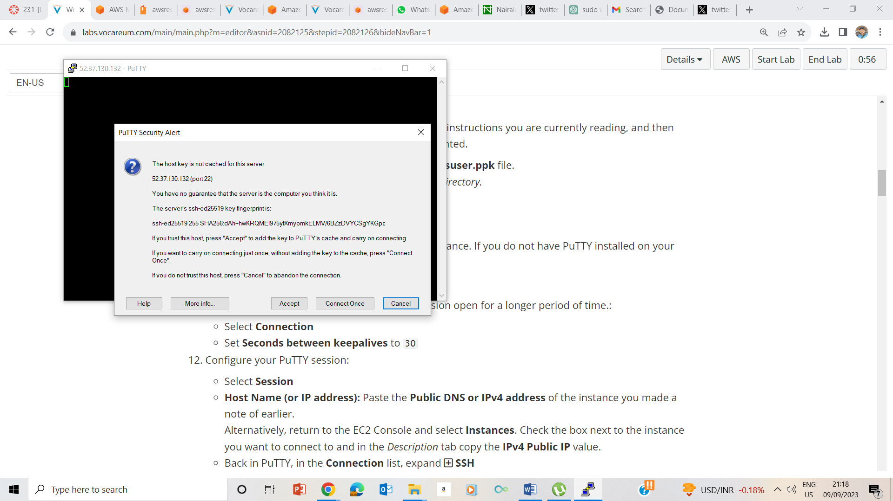

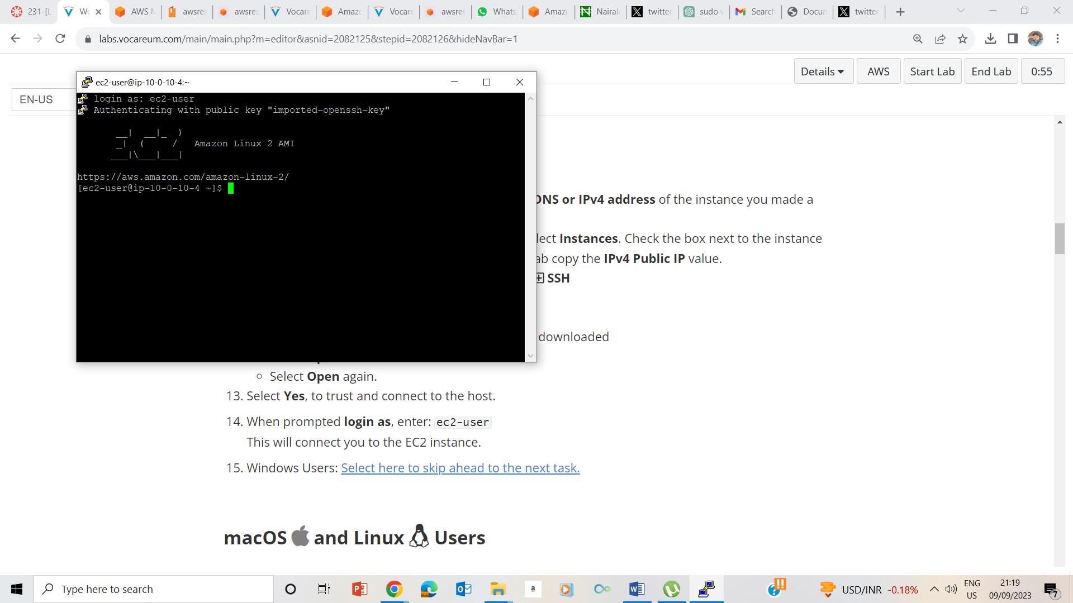

**Task 2: Exercise - run the Vim tutorial**

Write vimtutor and press enter-

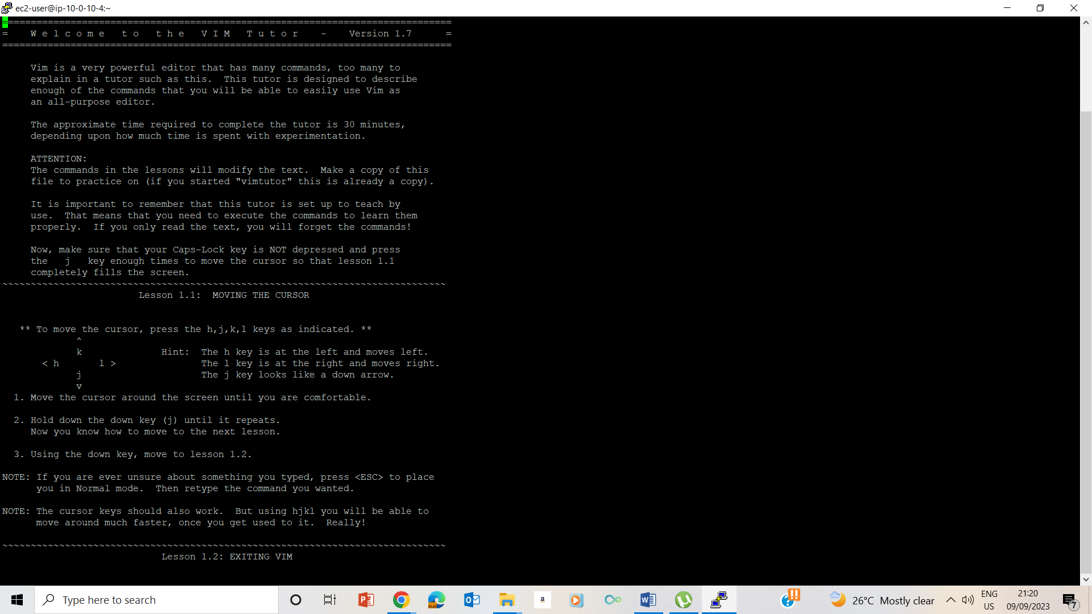

25. Press letter ‘j’ to movr down pressed letter ‘k’ to move up, pressed letter h to move left and pressed letter ‘l’ to move right.

I pressed :q! to exit vimtutor

## Task 3: Exercise - edit a file in Vim

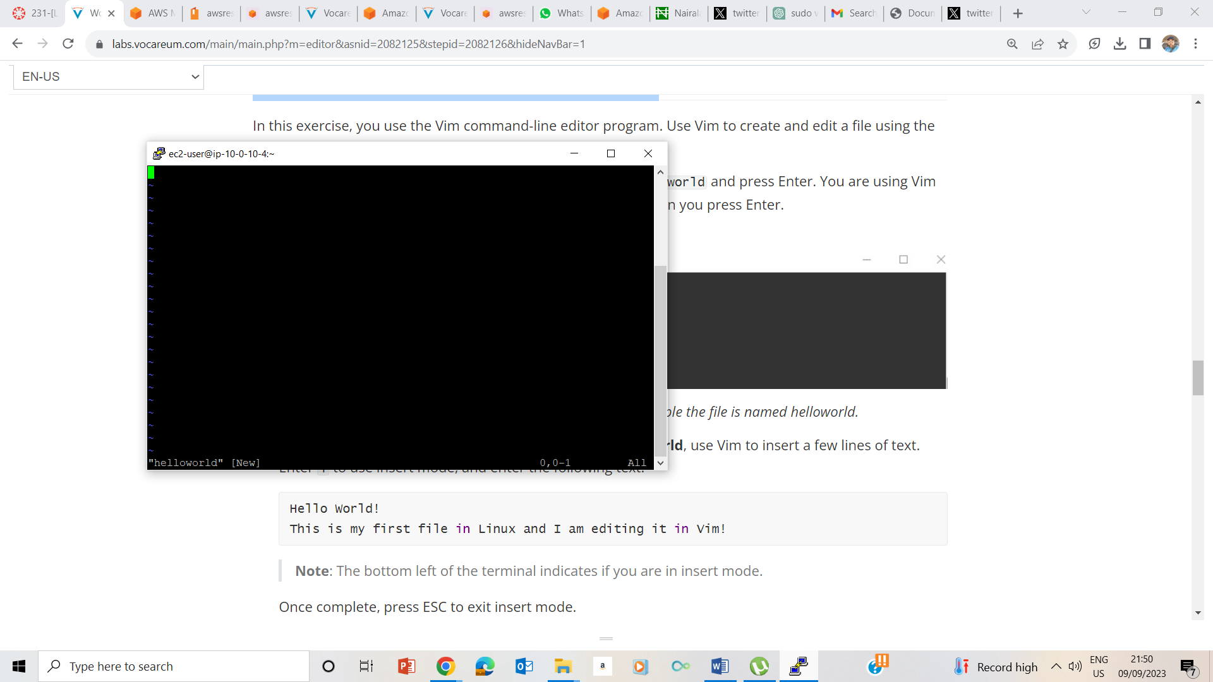I entered vim helloworld and the output screenshot is above

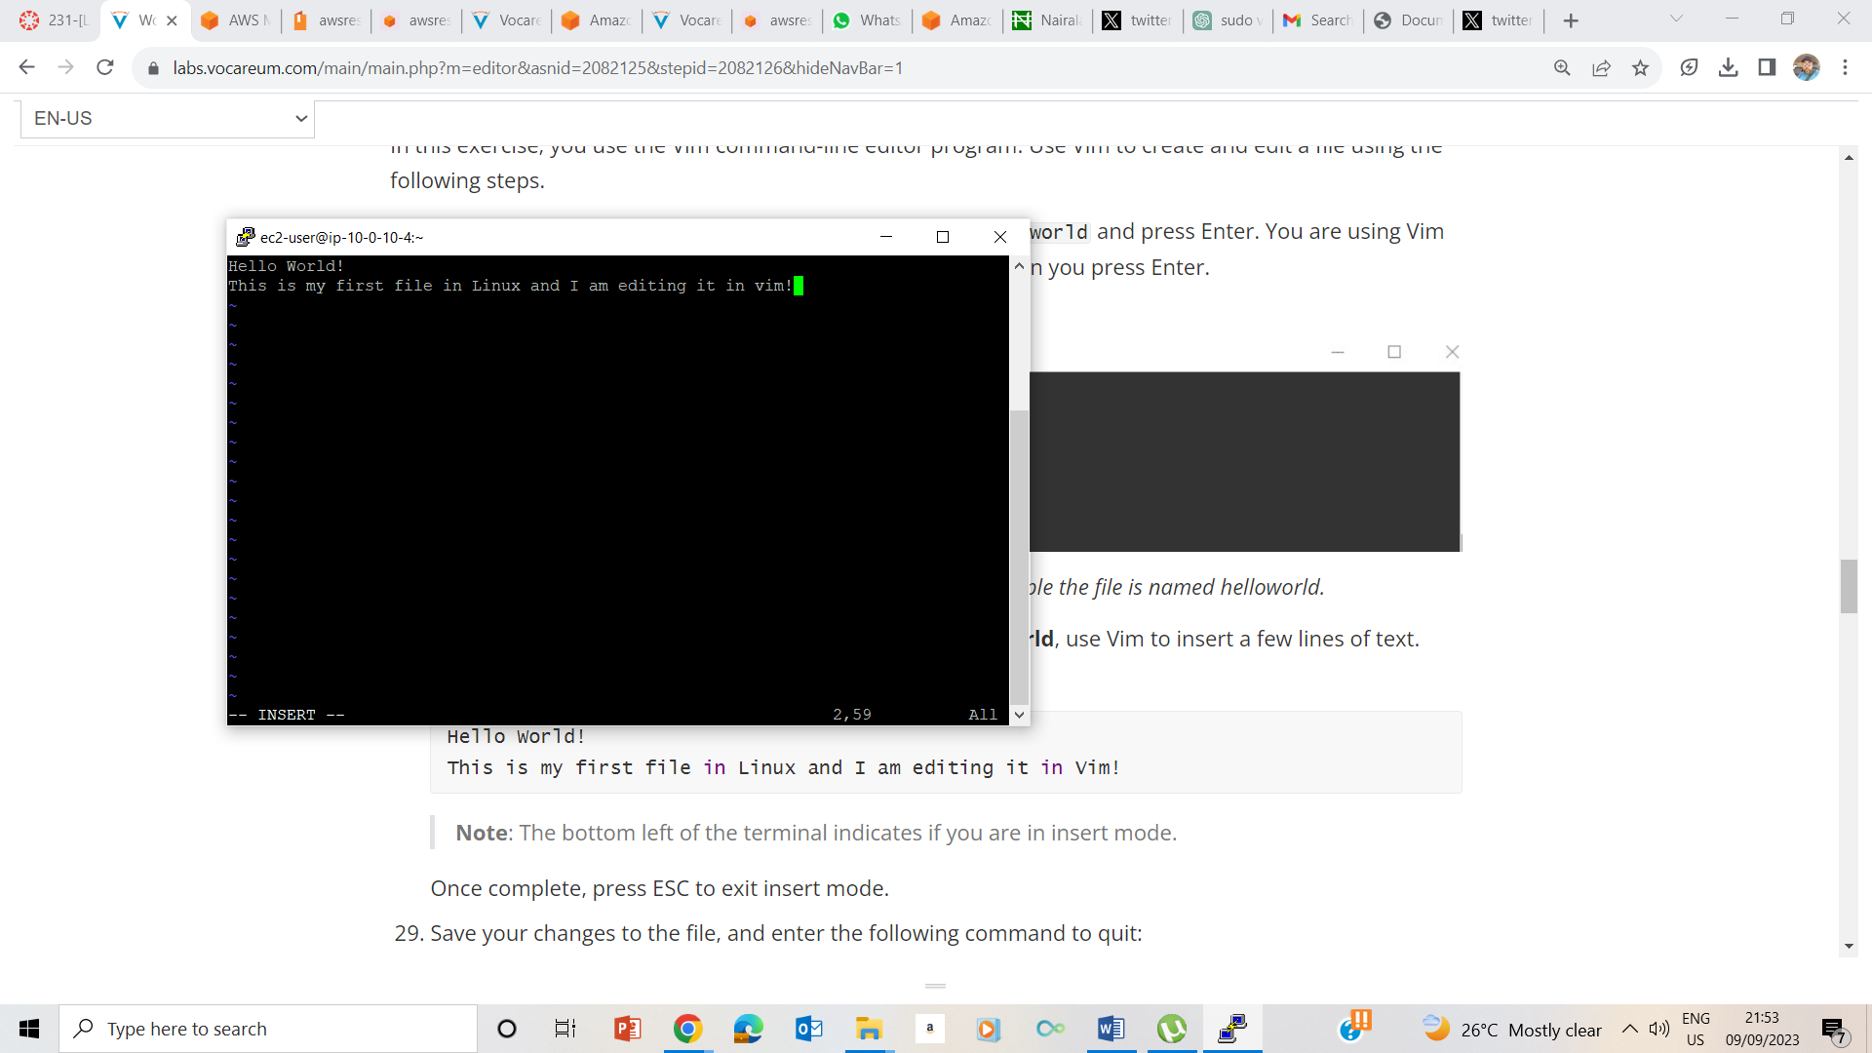

I typed :wq and pressed enter to exit vim mode

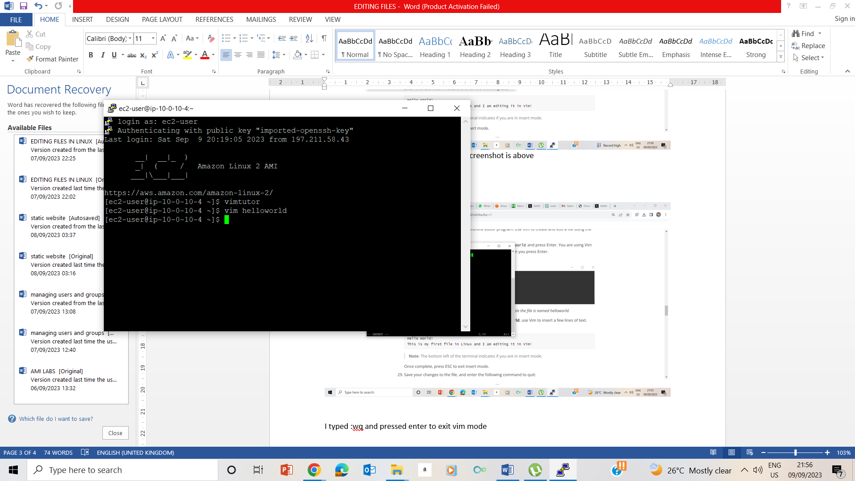

30 . I inserted the text ‘ I learnt how to create a file, edit and save them too. ‘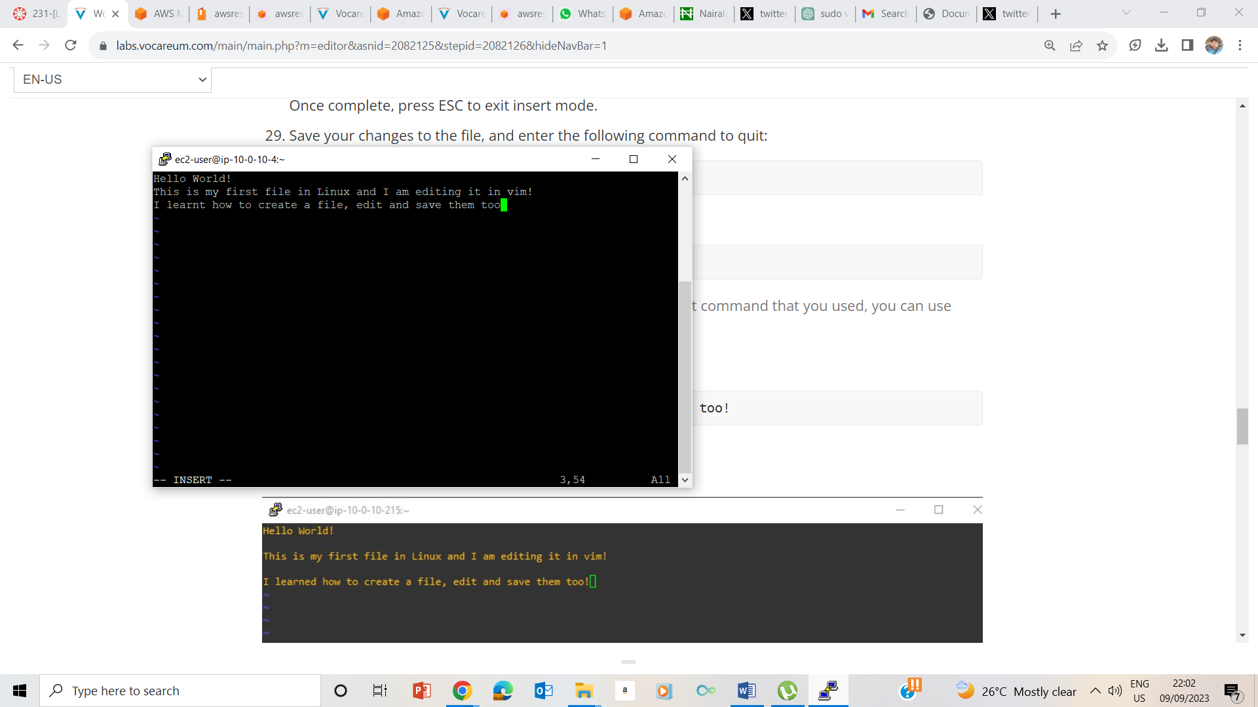

I pressed esc key to exit the insert mode, and used

33.the command ‘dd’’ deleted the previous line

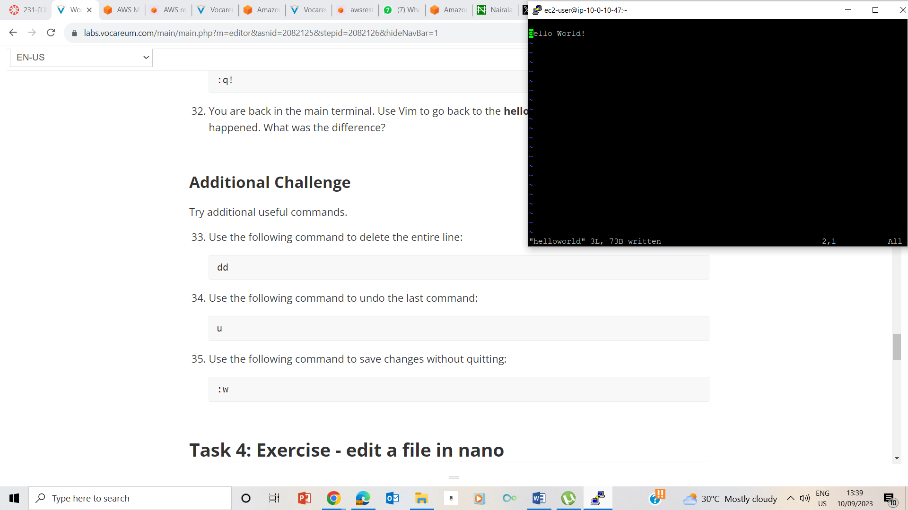

34. The command .u. undid my last command

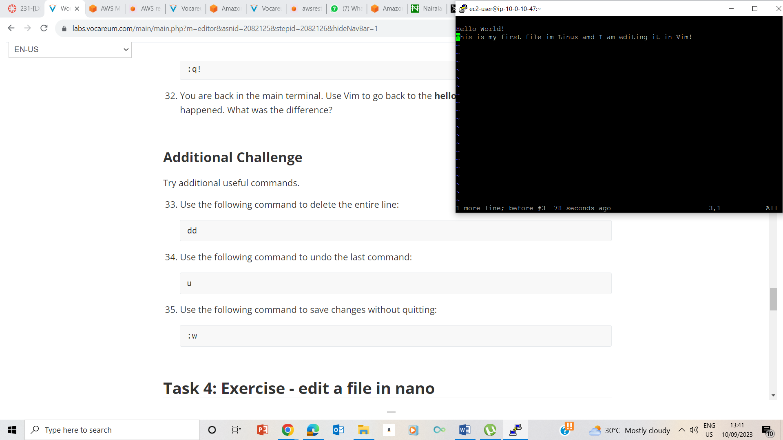

35. The command :w saved without exiting

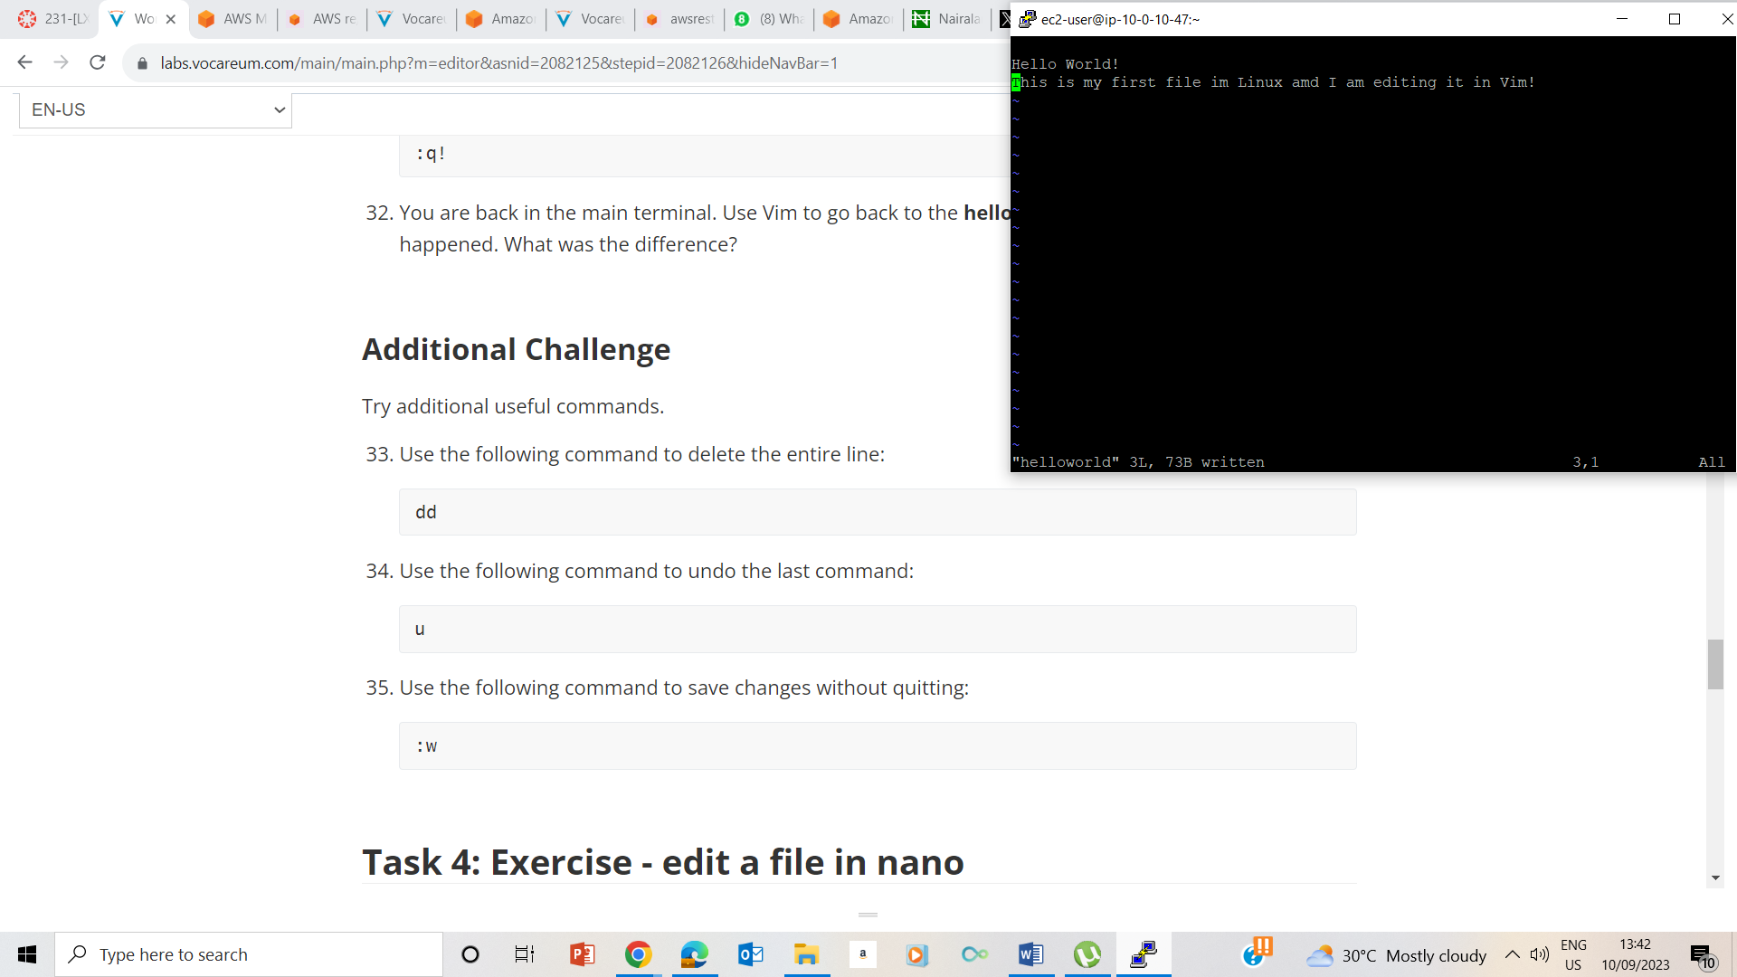

## Task 4: Exercise - edit a file in nano

Nano cloudworld takes us to a text editor terminal which we can just type

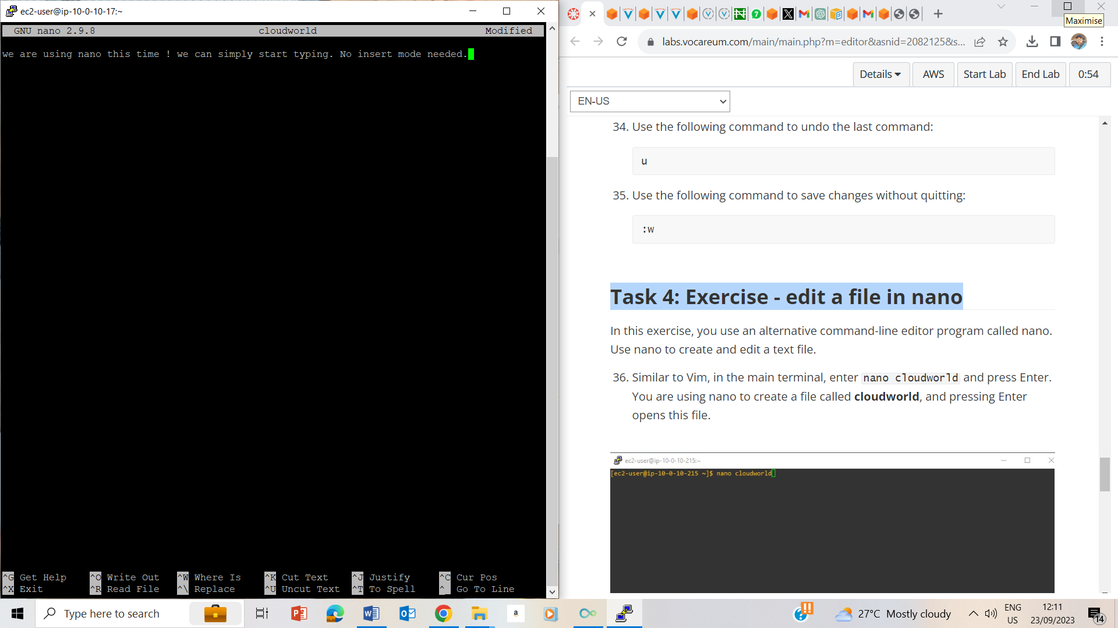



## Lab Complete

